**Task Overview**

Pick one of the two tasks below. You are free to use whatever language you are comfortable with, but just make sure you explain your thinking process whether through commenting your code or putting together a notebook (e.g. jupyter). The thought process is more important than getting the right answer. If you have questions, feel free to either leave comments here or email them to [yitaek@leverege.com](mailto:yitaek@leverege.com)

**Background Information**

In a typical asset tracking application, a GPS-enabled tracker is attached to a moving object (e.g. car) and analyzed for movement patterns. In this particular problem, we are tracking cars in a big auction lot. In this auction lot, cars are stored in “lots” which are encoded as GeoJSON polygons as shown below: (i.e. 415 lot is the pink lot towards the top of the auction ground).   
  
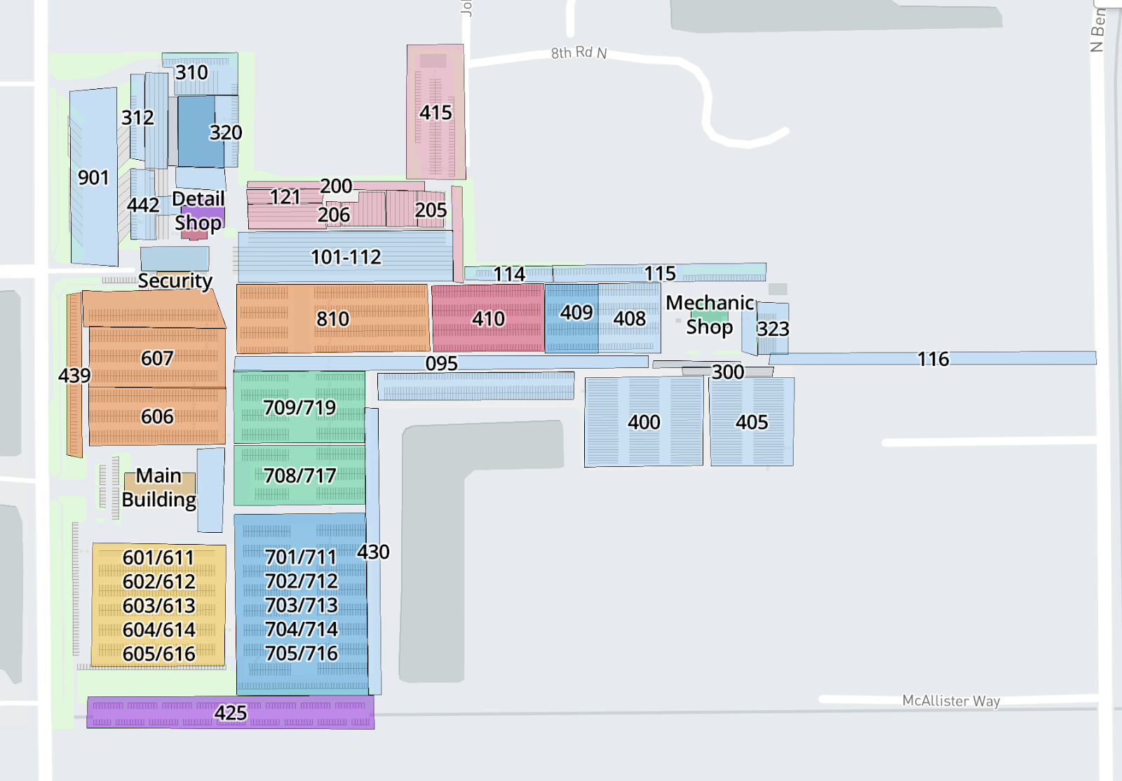

1. (Data Mining & Basic Analysis) This problem requires you to work with RESTful API endpoints and do some basic locational and time analysis.   
     
   To query the information about trackers and cars that are associated with trackers, you can do a GET call on the following endpoint: <http://pinpointapi.cox2m.com/v1/association?q=all>   
     
   The items array has two main objects (tracker and workOrder). Each tracker attached to a car will have a work order associated, whereas trackers not attached to cars will not have a work order associated. Each functioning tracker will have positional data given in lat/lon coordinates. This means that you will have to clean out the data for unassociated and non-functional trackers.   
     
   The task is to grab the data and analyze top five locations with most trackers. A tracker is in a lot if the GPS coordinate falls within the GPS coordinates of the GeoJSON polygon that defines each lot (see Supporting Materials). Make sure you attach the JSON file of when you pull the data so we can verify the work. Please also comment on some characteristics of each of the lots (e.g. does this lot store a certain make/model/year/color of cars, trackers in this lot display a certain level of battery level, etc).   
     
   BONUS: Run a chron job or some repeating process to analyze how these patterns change over a day or week.
2. (Machine Learning & Server Setup)   
     
   Due to the inherent inaccuracies of GPS, a tracker might report a faulty position. For example, consider this car. Even though it is reporting that it isn’t within one of the defined lots (colored areas), it’s most likely parked within lot 205 or 200.   
     
   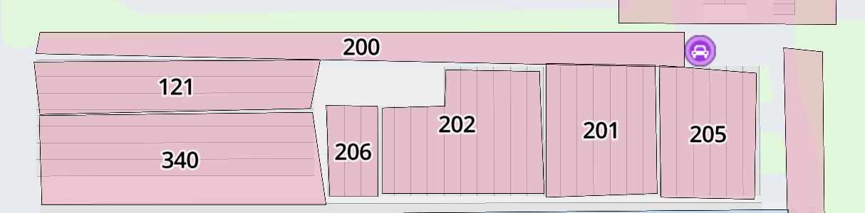  
     
   Your task is to train a machine learning algorithm (pick any algorithm and justify your choice) given the csv file (see supporting materials) so all trackers missing a lot location is given one. Feel free to use any of the categories provided to you as a training variable, but also justify why you chose or did not choose that category for your algorithm of choice. You may also decide to clean the data to throw away anomalies (e.g. trackers with no GPS data), and again just make sure to explain your reasoning.   
     
   BONUS: Turn your algorithm into a machine learning server (i.e. provide an endpoint so that a user can request the variables you chose and get a lot location back).

**Supporting Materials:**

1. GeoJSON of Lots: lots.json
2. CSV of tracker/car information: lotUnassigned.csv